**USER GUIDE FOR QUIZ-MANAGER APPLICATION**

## 1. Login to application. If you have logged in once, the application will automatically get your information.

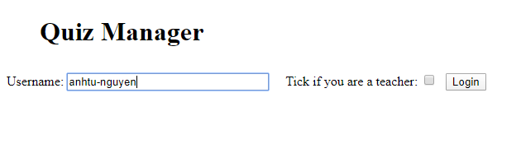

## 2. If you are a teacher, you will be able to access to Exam Management, Question Management, Take an Exam. Else, you can access to Take an Exam only.

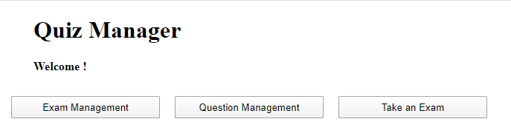

## 3. Exam Management: You will see a table of existing exams here. Click create exam if you want to add more exam, click show to show details of each exam and edit them.

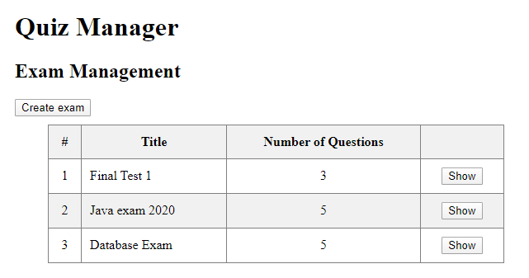

## 4. In Create exam:

* First: enter exam title

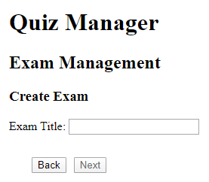

### Then choose questions that you want to add into the exam, by checking the checkbox next to each question. If there are no question to choose, you have to go back to Question Management and create some first.

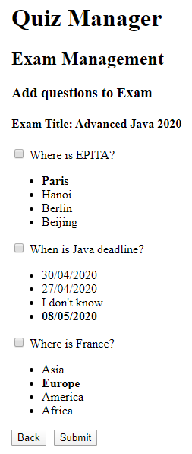

## 5. In edit exam: You enter ‘Edit Exam’ by clicking ‘Show’ button next to each exam, then you can add/remove questions or edit exam title.

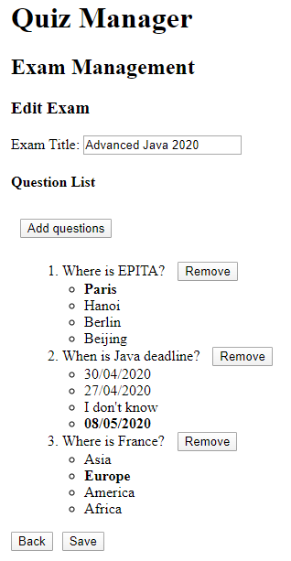

## 6. In Question Management: you will see a list of all questions in the program. To create question, click ‘Create question’. You can edit each question as well.

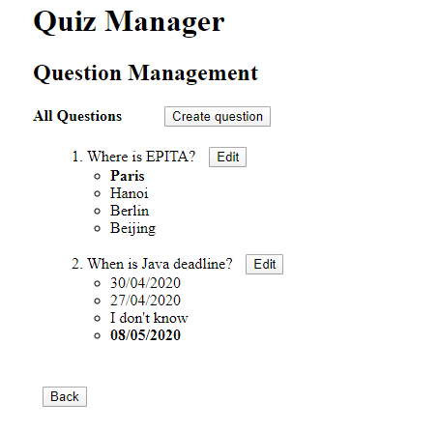

## 7. In ‘Create question’ or ‘Edit’: You have to enter question title and choices’ content and choose which choice is a correct answer.

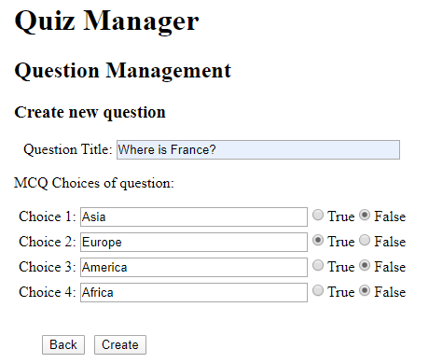

## 8. Take an exam: click button Take exam to start doing an exam.

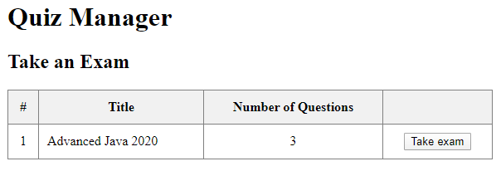

## 9. In taking exam:

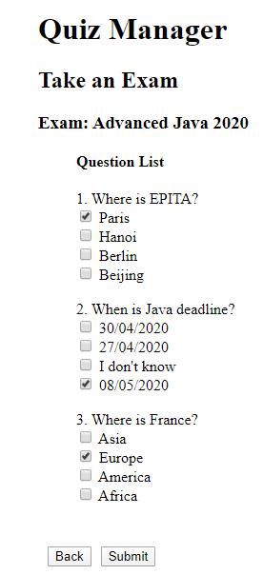

## 10. After finish the exam, you will receive your grade:

